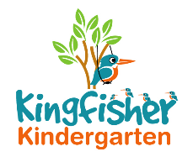
Privacy Notice Policy
Children’s information that we collect, hold and share include:

• Personal information such as name and address and date of birth
• Characteristics such as ethnicity, language, nationality, country of birth
• Attendance information such as sessions attended and number of absences
• Other – Assessment information, relevant medical information and SEND

Why we collect and use information and we use the children’s data:

• To support children learning
• To monitor and report pupil progress
• To provide appropriate pastoral care
• To assess the quality of our services
• To comply with the law regarding data sharing
• To ensure the safety and well being of the children
• To enable emergency contact should this be necessary

Who we routinely share children’s information with:

• Schools and other settings
• Our Local Authority
• Department of Education and Ofsted.

This policy was adopted by Kingfisher Kindergarten Ltd

On 22nd January 2019
Date to be reviewed Annually
Signed on behalf of the provider La-Ryne Baker
Role of signatory Owner

